Your new Talkbox Device

Thank you for purchasing the TalkBox. Included Contents contain : A talkbox device
10 complementary preset slides. Not included is the usb and the configuration software which is free but will have to be downloaded off our github page. A Usb containing the free configuration software is required for use with the device, a computer with access to a microphone and basic audio output is also required to use the configuration app.
Is this product right for you?

- The Talkbox is a highly affordable assistive speech device intended for use with individuals who have difficulty speaking as well as may have mobility issues that may not allow them to use a standard keyboard. It feature expressions to be conveyed by the user. This may range from expressing basic needs like hunger or a set of expressions that can be used to answer course specific questions in a classroom setting.

Typical Use case

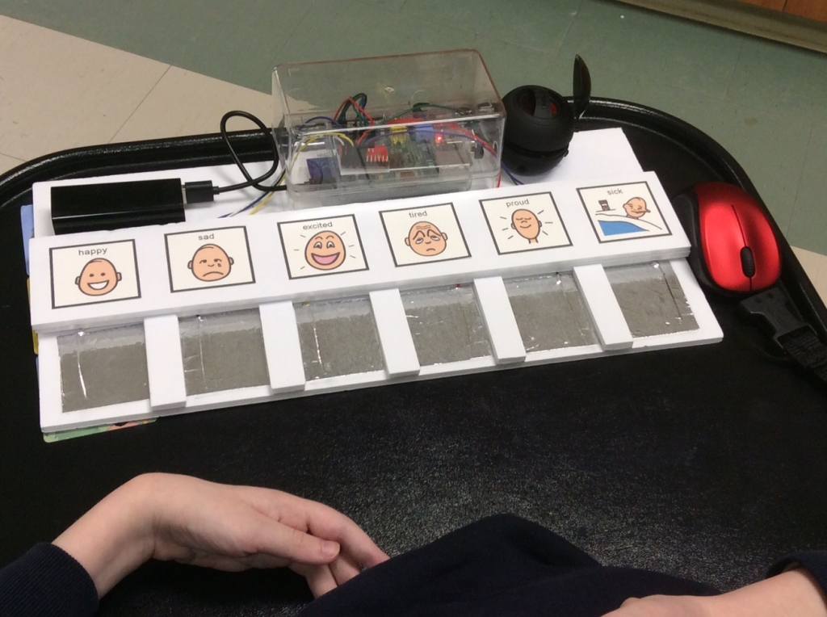

The device features several configurable tactile speech buttons that when pressed will trigger an audio sample containing a custom phrase in order to convey an expression by the user. This device features a photo above each expression as a visual indicator of the expression triggered to assist in the ease of use.
There are also one or more toggle buttons that allow switching between presets.
A preset is a row of buttons featuring unique expressions that typically follow a pattern. An example of a preset is expressions that express the user’s current mood as per the picture. Other examples include,
current weather, physical needs, mathematical expressions or anything that may assist the user in conveying an expressions that needed for their specific daily activities.

Toggle buttons : The device will contain one or more toggle buttons, the last toggle button will always cycle through the remaining presets while the former toggle buttons will each be designated to a particular preset. The intent of this design is that should the user have a preset/s that contain
expressions that have a sense of urgency (ex: washroom access) the user will not have to waste time cycling through presets but rather hit the toggle button to arrive at the mentioned preset quickly.

Configuring the Talkbox through the Configuration App

As mentioned before the Talkbox will contain a row of buttons that will trigger audio files based on the current preset selected. Given proper configuration of the device and undamaged physical components we guarantee this product will do so. The device will be configured through a configuration app stored on a usb. The configuration app is intended to be used by the caretaker of the user of the Talkbox.In order to use the configuration app the caretaker will need to put the usb into a computer that has access to a microphone and basic audio output. Once configured the Usb will be inserted into the talkbox device and automatically configured the device with the current desired presets. It will contain features that allow the caretaker to record audio
files to be played upon pressing a button. It will allow the caretaker to set the layout of the preset and decide which button will play which file. It will allow the caretaker to select which presets will be currently stored onto the talkbox as there are optionally many presets that can be used and stored that may not be currently used on the talkbox but may of be use at a later time.

The app contains 2 main menus. The first menu is Simply a menu to select which presets( Of the ones stored in the library) will be put the talkbox device at the current time as well as select which presets will correspond to which toggle buttons. The second menu is the preset editor, this menu will allow the creation and editing of presets. The caretaker will have access to recording individual expressions and designating them to their spot in the preset. Once a preset is full they will be able to save it into the library. Should the instructions in the user manual be followed for the configuration app we guarantee that the usb will properly transfer the currently selected presets to the talkbox.

